***Hand Made Quilts***

* AutumnQuilt

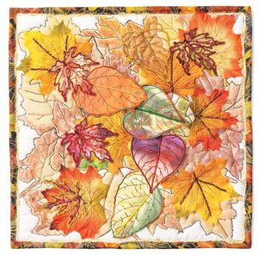

Source: <http://www.quiltingdaily.com/blogs/handmade_quilt_art/archive/2012/10/25/fall-art-quilts.aspx>

* Scrap Quilt

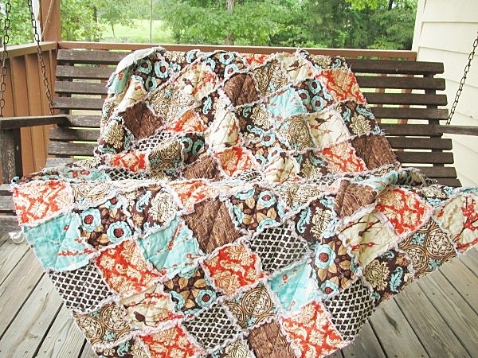

Source: <http://southerncharmquilts.com/item_519/Rag-Quilt-Throw-Large-Aviary-2-in-bark-ALL-NATURAL-fresh-modern-handmade.htm>

* Log Cabin Quilt

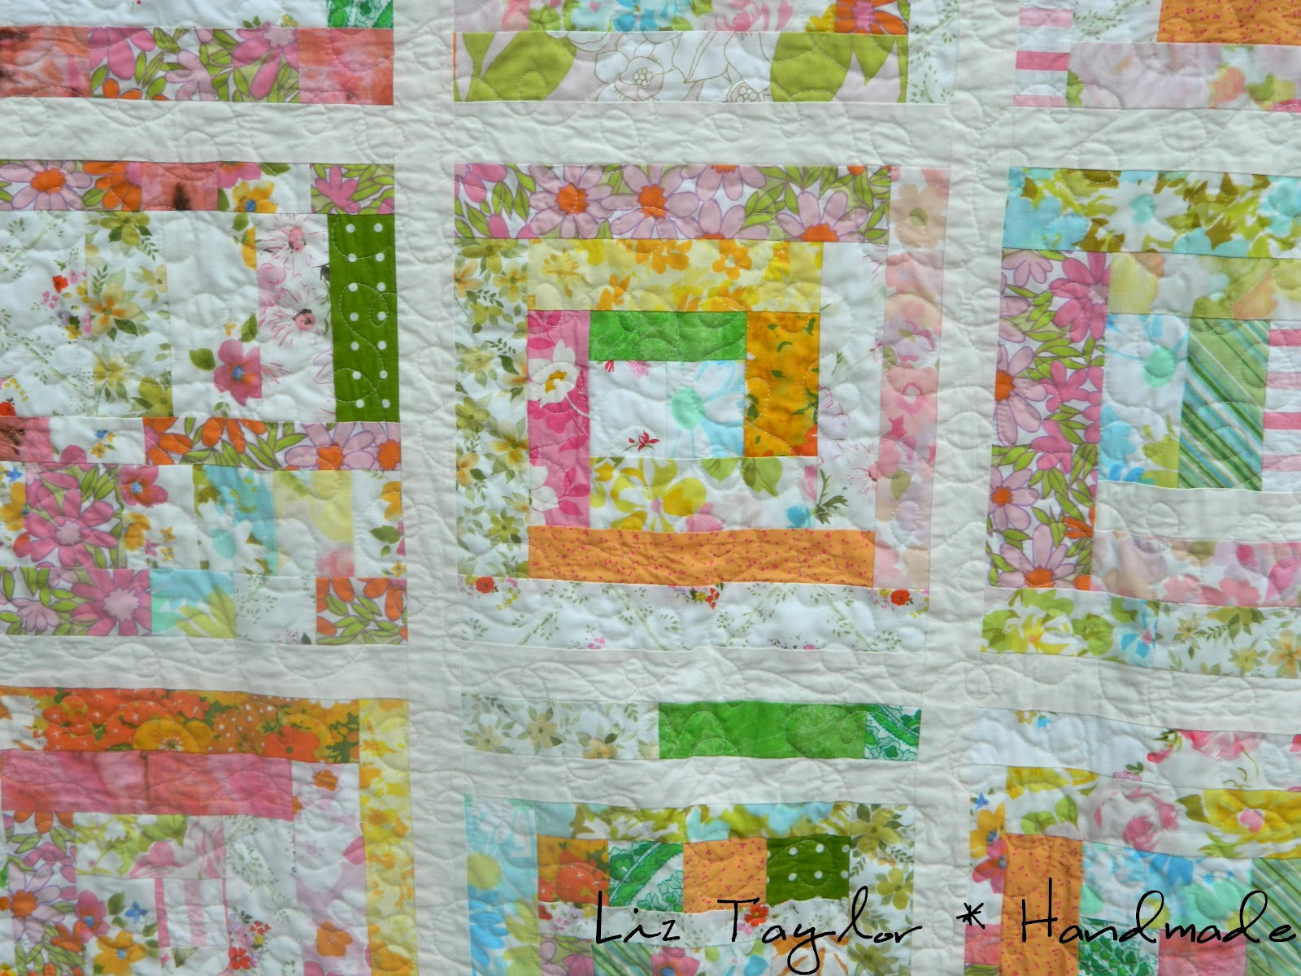

Source: <http://www.liztaylorhandmade.com/2012/07/scrappy-log-cabin-quilts.html>

* Portland Roses Quilt\

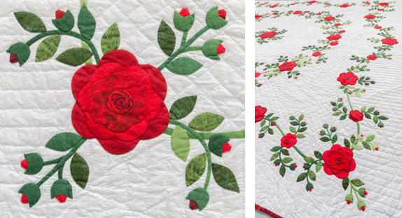

Source: http://blog.shopmartingale.com/quilting-sewing/how-to-quilt-by-hand-for-beginners/

* Hands Quilt

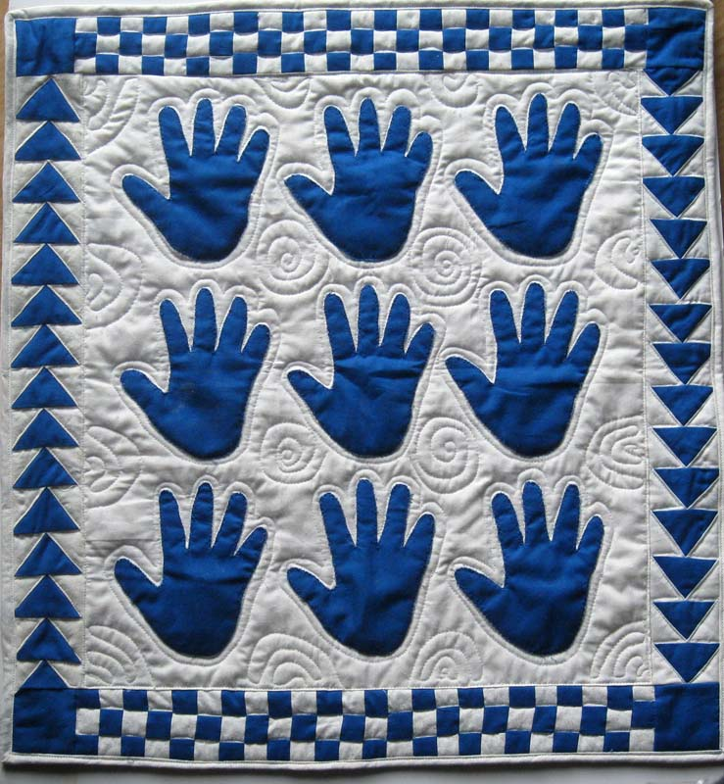

Source: <http://gefiltequilt.blogspot.com/2013/01/a-great-grandma-gift-hand-quilts.html>

* Orange Peel Quilt

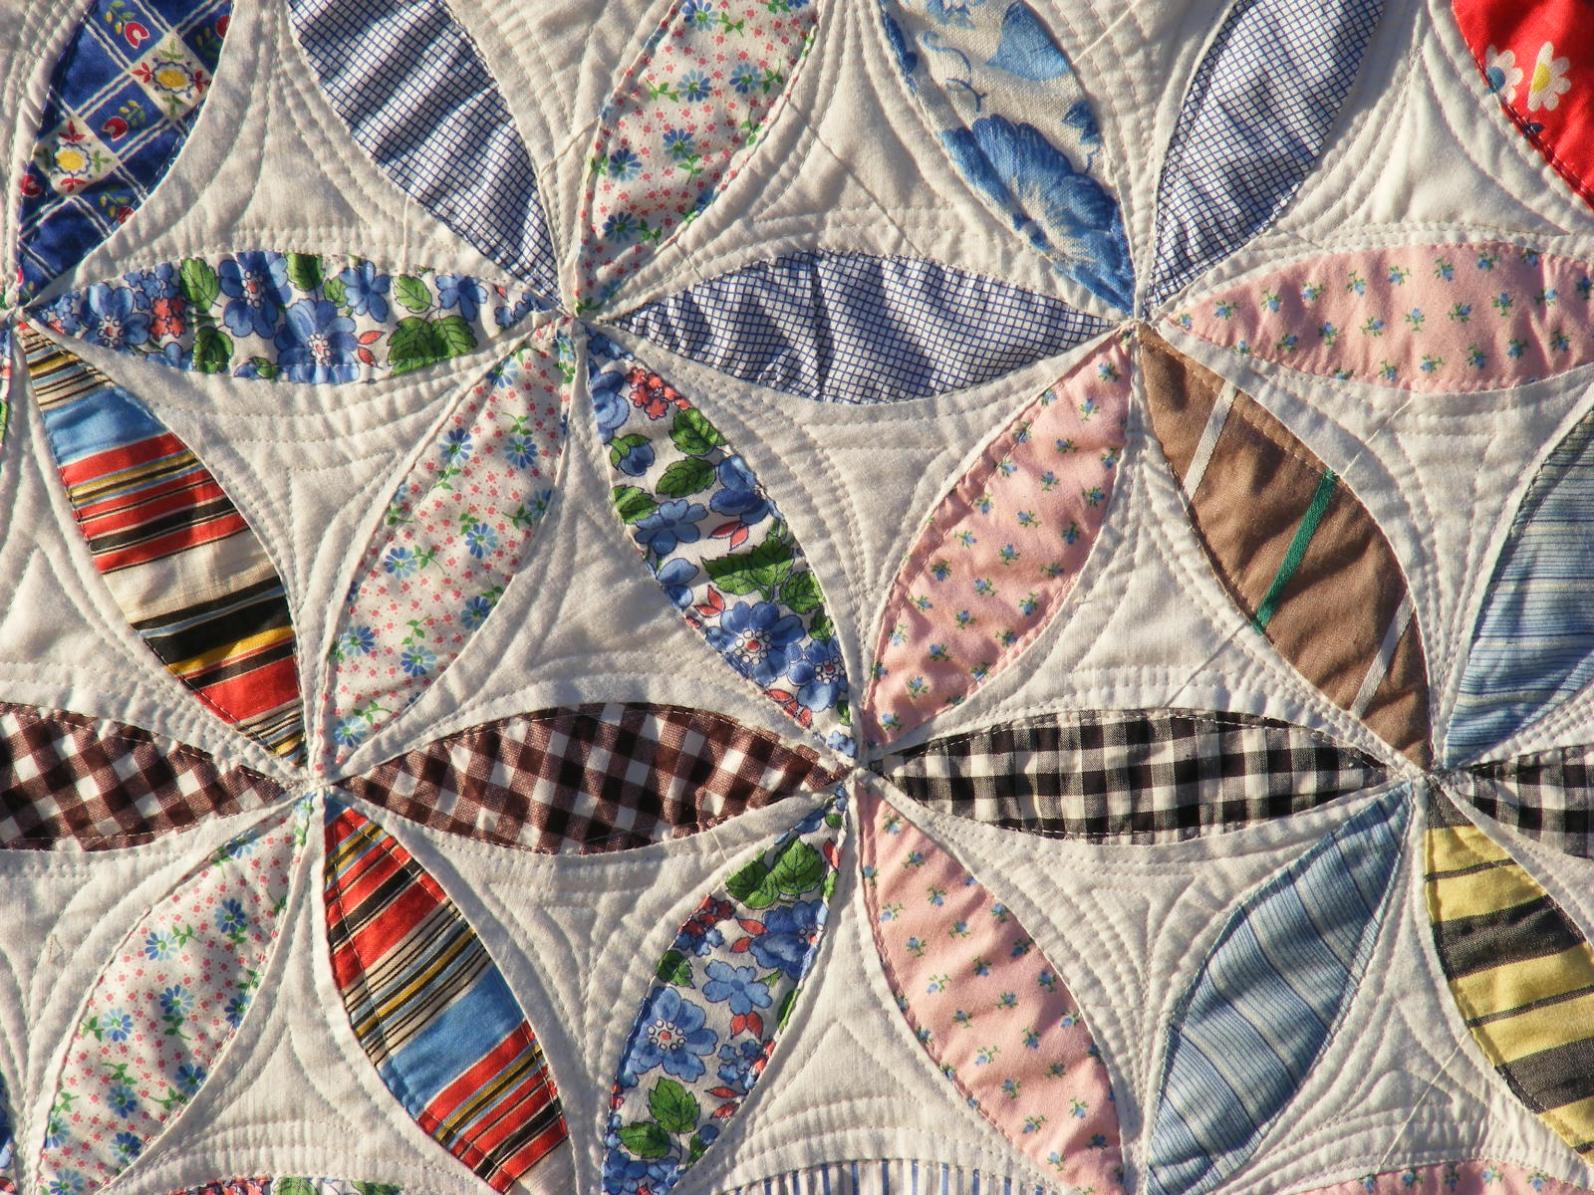

Source: <http://tiacurtisquilts.blogspot.com/2012/01/orange-peel-quilt.html>

***Machine Quilts***

* Machine Sampler Quilt

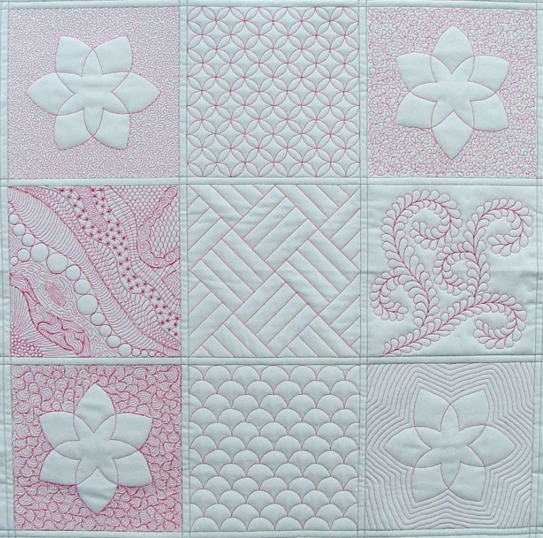

Source: <http://kathykwylie.com/machine-quilting/>

* Triangle Quilt

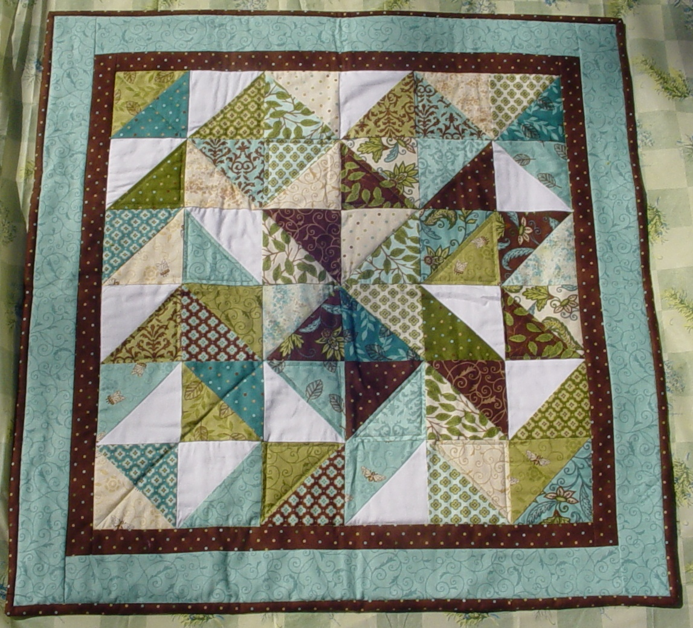

Source: <http://www.quiltersnewsletter.com/blogs/insideqn/2011/01/28/adventures-in-machine-quilting/>

* Butterfly Quilt

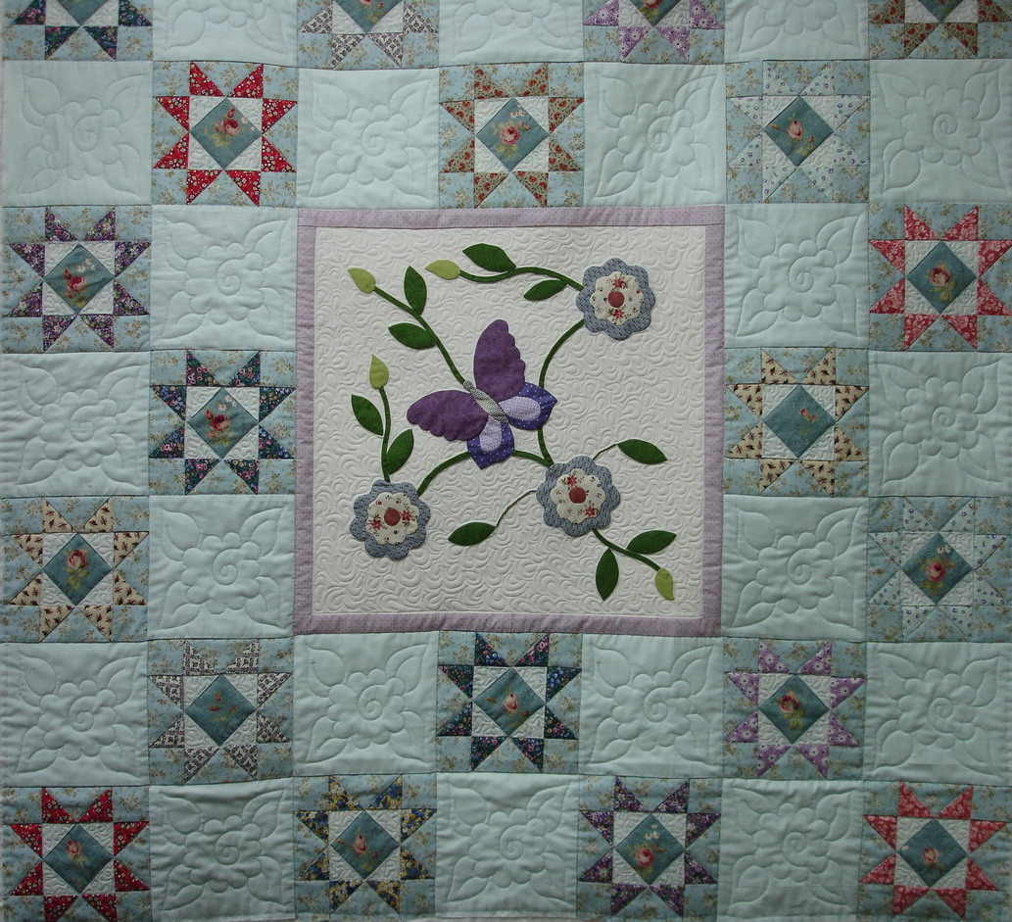

Source: <https://alwaysmachinequilting.wordpress.com/>

* Flowers Quilt

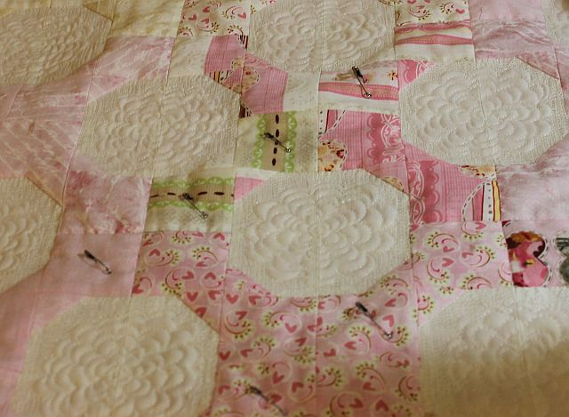

Source: <http://christaquilts.com/page/29/?themes_on_signup_preview=1>

* Long Arm Flower Quilt

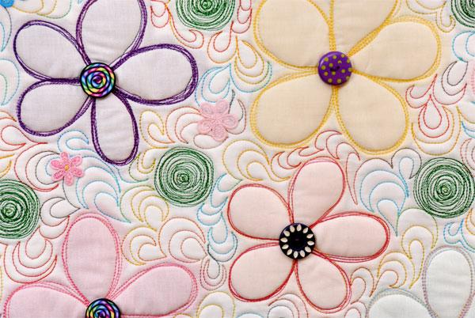

Source: <http://www.rasmatazzdesigns.com/?a=SM>

* Feather Quilt

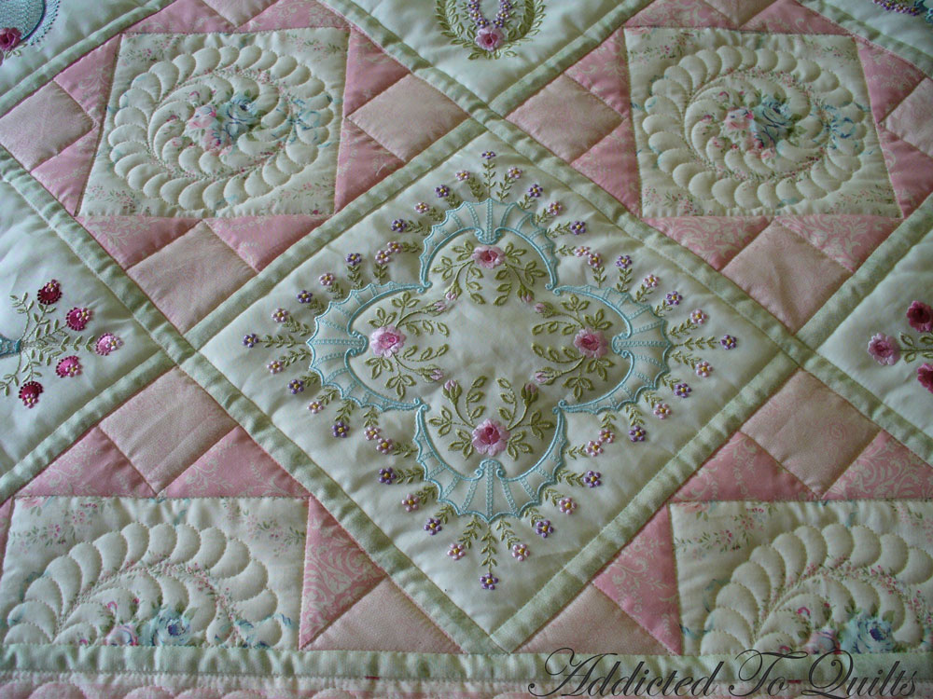

Source: <http://addictedtoquilts.blogspot.com/2012/02/two-pretty-embroidery-quilts.html>

* Purple Flowers Quilt

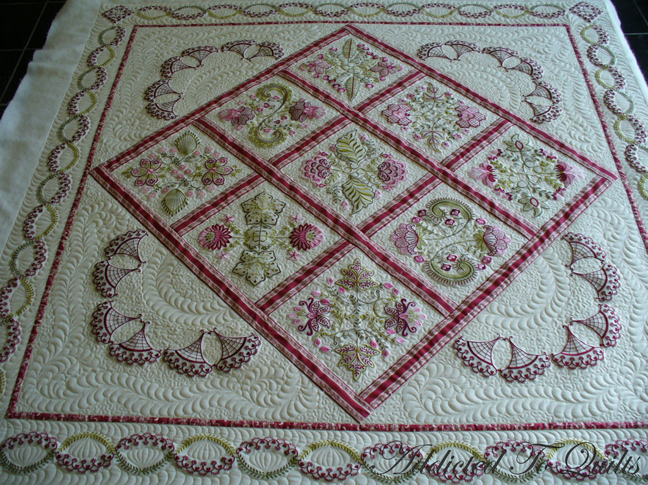

Source: <http://addictedtoquilts.blogspot.com/2012_06_01_archive.html>

***Patch Quilts***

* Hearts Quilt

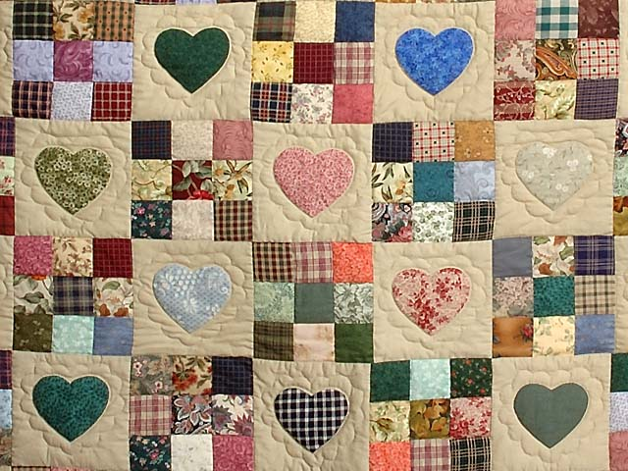

Source: <https://www.amishcountrylanes.com/Pages/hs2637.shtml>

* Diamond Patch Quilt

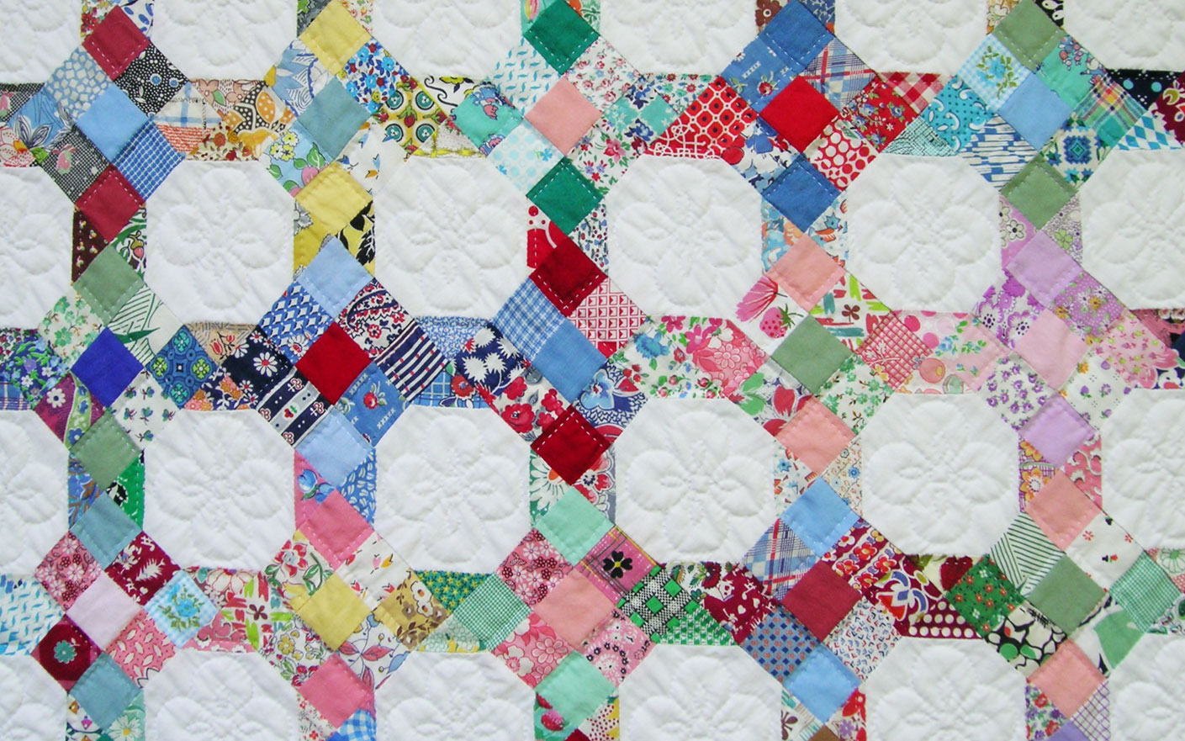

Source: <http://qisforquilter.com/2009/07/9-patch-and-snowball-quilt/>

* Cresent Quilt

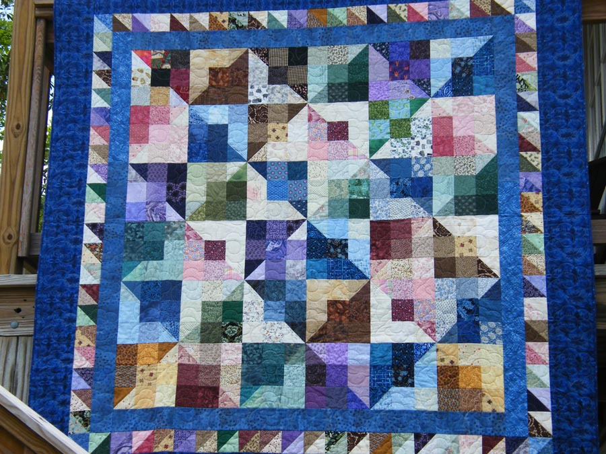

Source: <http://quiltingcrescent.blogspot.com/2012/05/spring-2012-bloggers-quilt-festival.html>

* Nine Patch Quilt

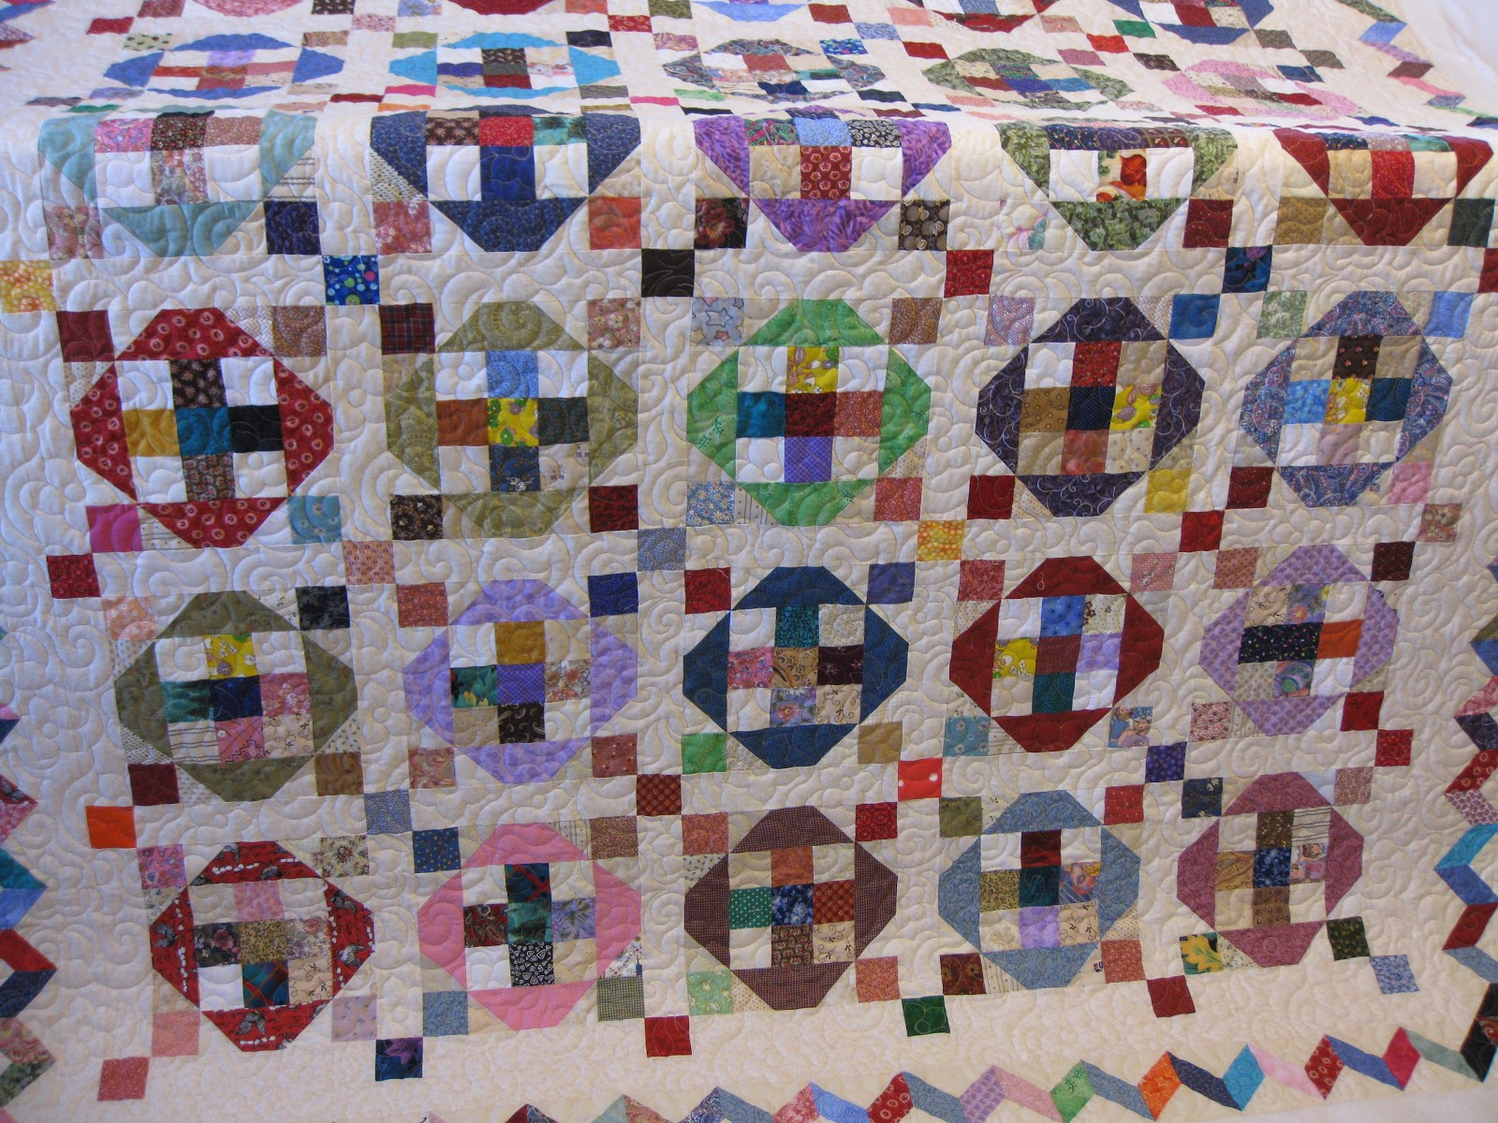

Source: <http://milliesquilting.blogspot.com/2013/02/scrappy-quilts.html>

* Disappearing Nine Patch Quilt

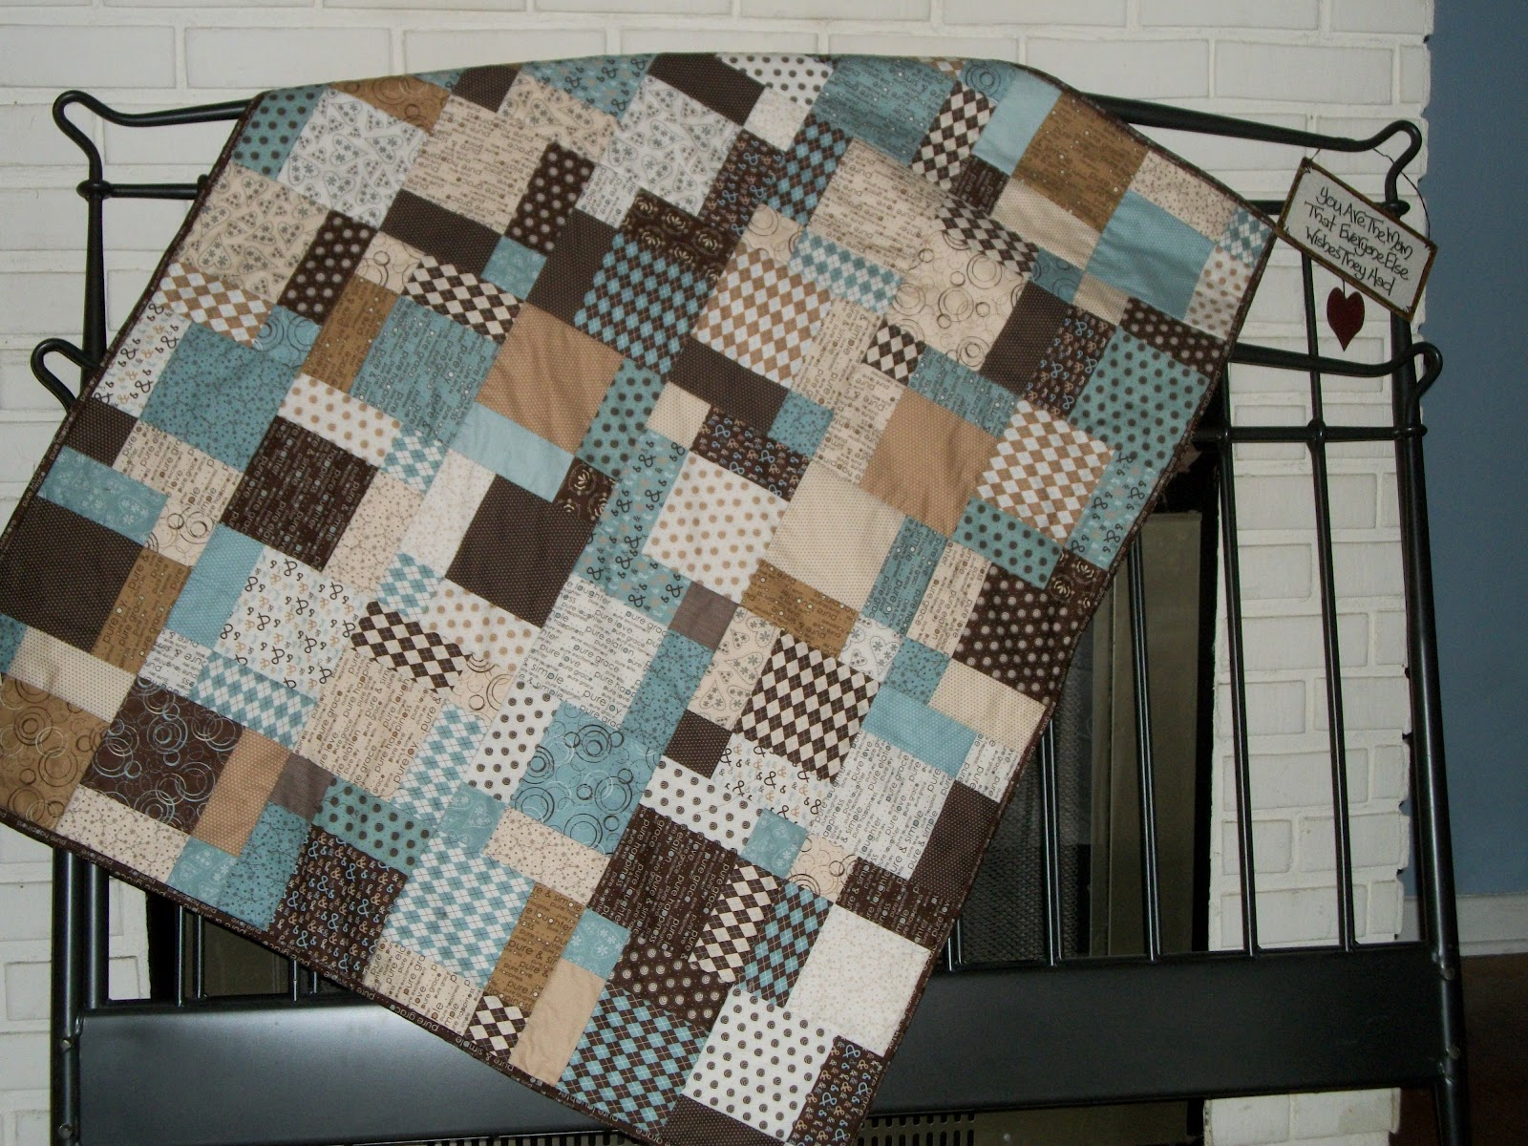

Source: <http://craizeecorner.blogspot.com/2012/03/disappearing-9-patch-and-eq.html>

* Penguin Quilt

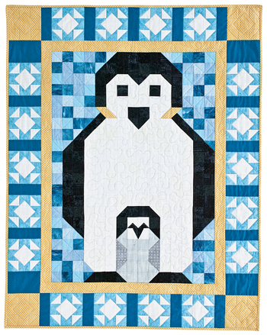

Source: <http://www.quiltmaker.com/slideshows/index.html?slide_id=2126>

***Applique Quilts***

* Garden Quilt

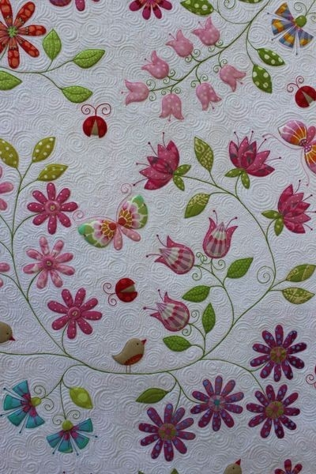

Source: <http://indulgy.com/post/2fZA2h8QD1/gorgeous-applique-quilt>

* Poppies & Daises Quilt

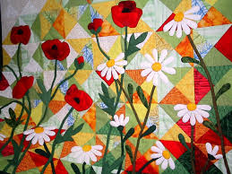

Source: <http://www.pinterest.com/pin/76350156155602543/>

* Love Birds Quilt

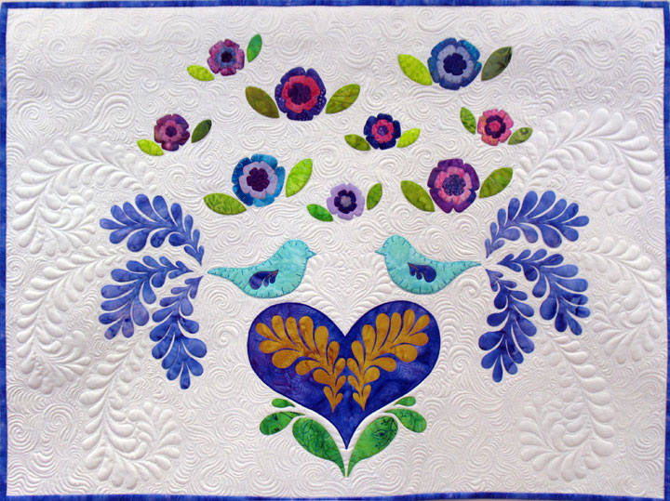

Source: <http://www.patsythompsondesigns.com/blog/index.php/archives/date/2011/02>

* Peacock Quilt

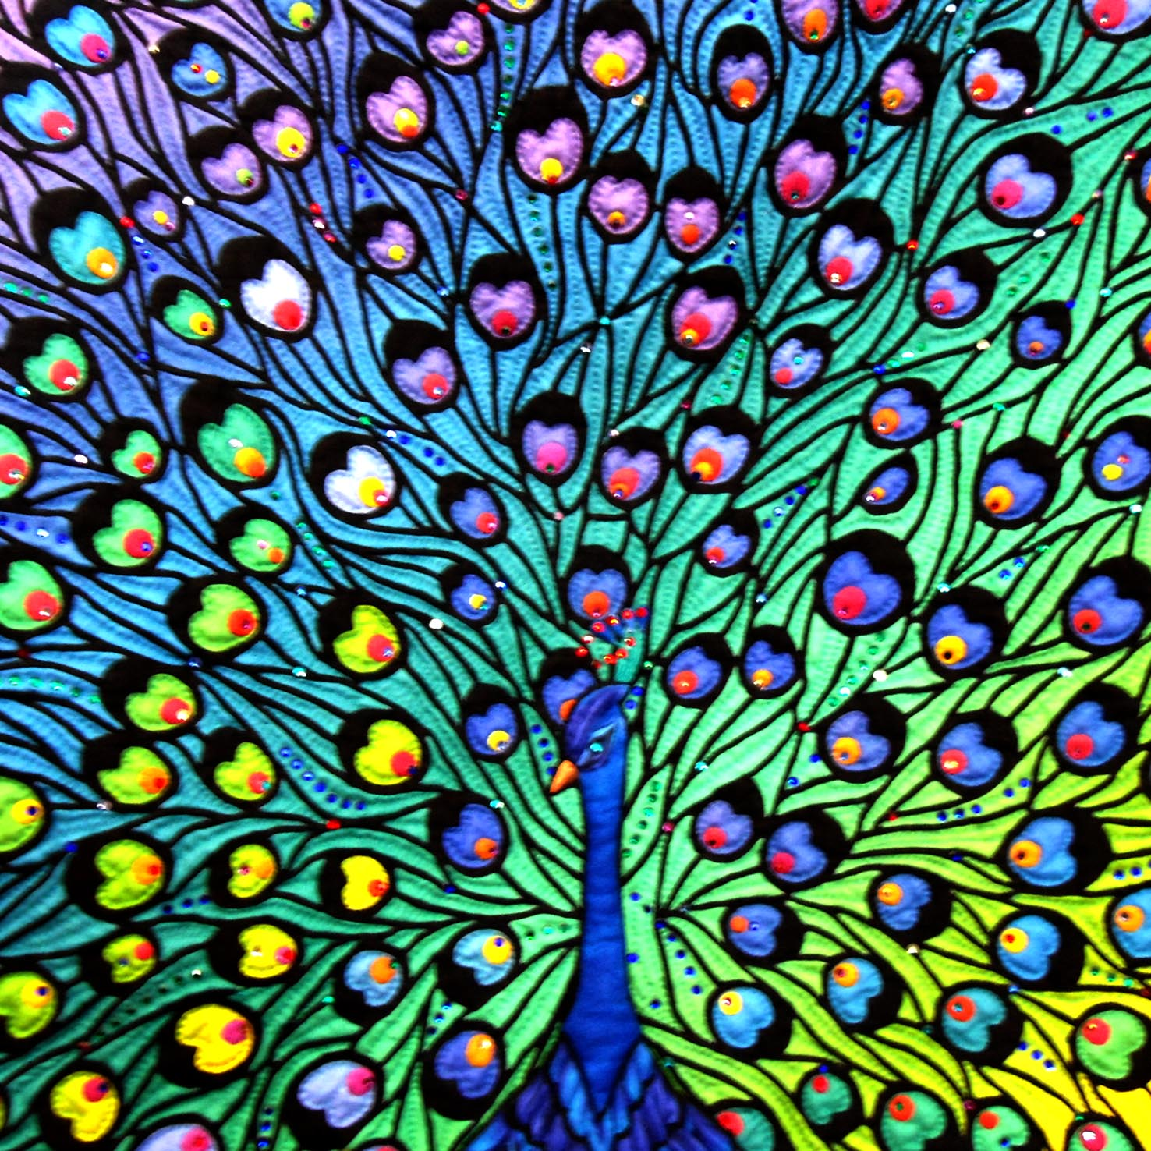

Source: <http://www.thimblelady.com/pages.php?pageid=50>

* Flower Petals Quilt

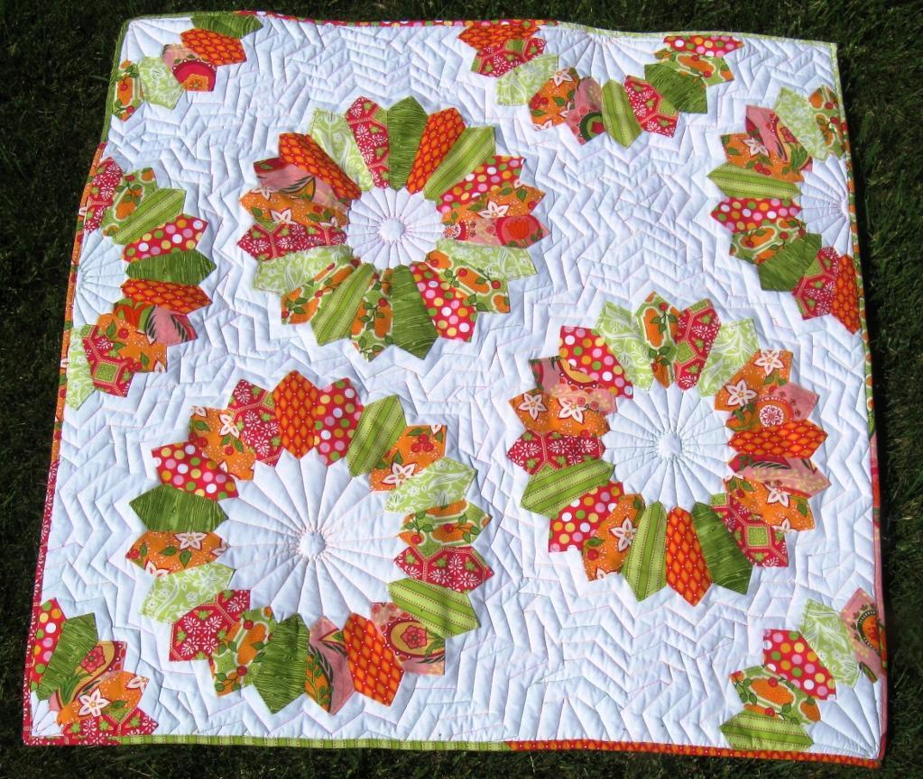

Source: <http://www.craftsy.com/blog/2013/08/applique-quilting-by-hand-or-machine/>

* Teapot Quilt

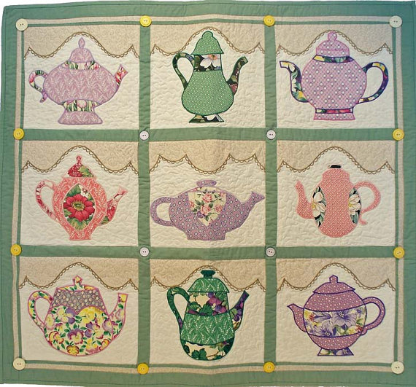

Source: <https://www.etsy.com/listing/158315767/teapot-collection-machine-applique-quilt>

***Pieced Quilts***

* Strips Quilt

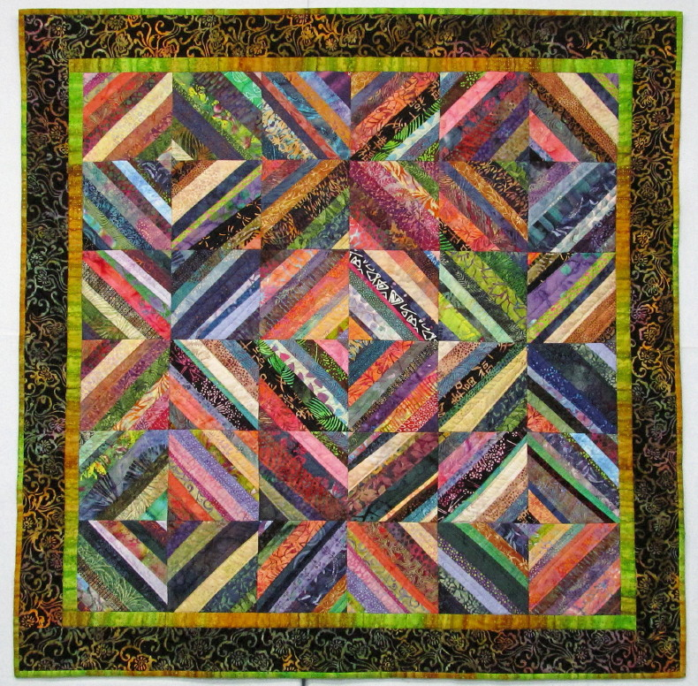

Source: <http://exuberantcolor.blogspot.com/2012/11/string-pieced-done.html>

* Snowflake Quilt

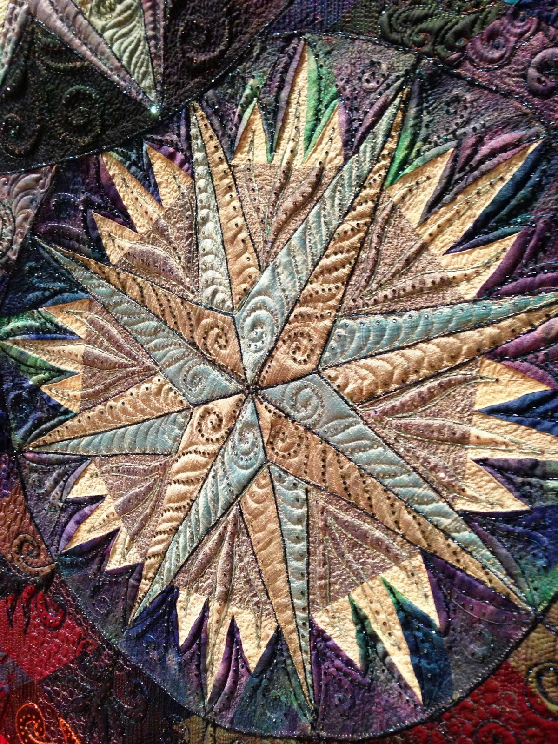

Source: <http://fluffysheepquilting.blogspot.com/2013/06/iqfoi-2013-pieced-quilts.html>

* Red Fox Quilt

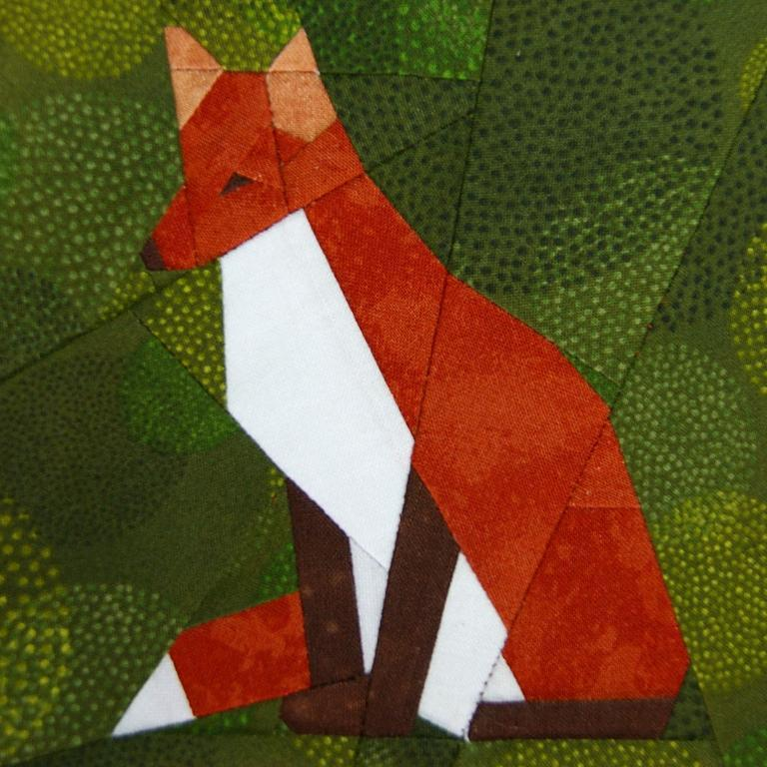

Source: <http://www.craftsy.com/pattern/quilting/other/red-fox-paper-piecing-/49080>

* Woven Ribbons Quilt

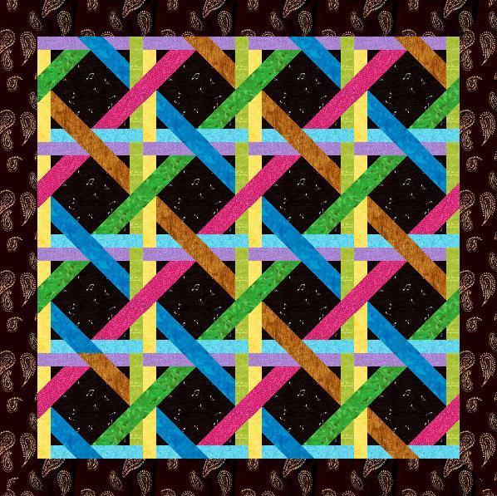

Source: <http://www.craftsy.com/pattern/quilting/other/woven-ribbons-paper-pieced-quilt-block/19202>

* Neutral Curves Quilt

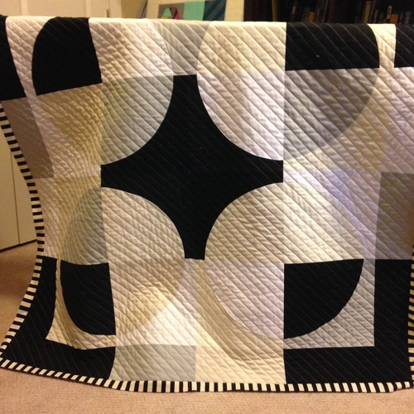

Source: <http://ecoslo.tumblr.com/post/101416460992/neutral-curves-quilting-complete-i-finished>

* Modern Nine Patch Quilt

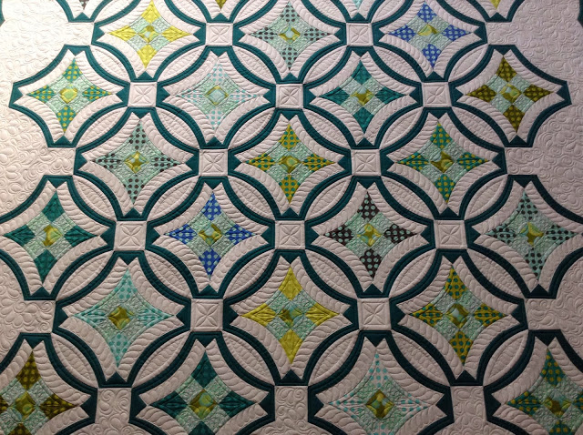

Source: <http://sewkindofwonderful.blogspot.com/2013/11/this-is-itmy-last-customer-quilt.html>

***Amish Quilts***

* Polynesia Sky Quilt

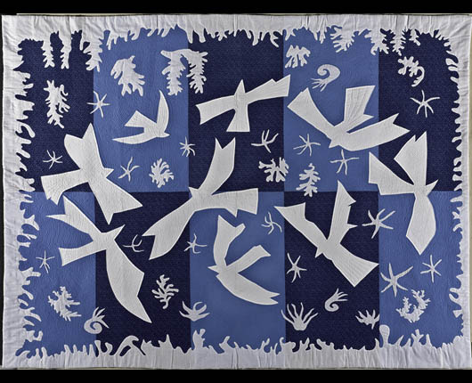

Source: <http://www.americanstyle.com/2011/09/arts-focus-the-art-of-the-quilt/>

* Double Wedding Ring Quilt

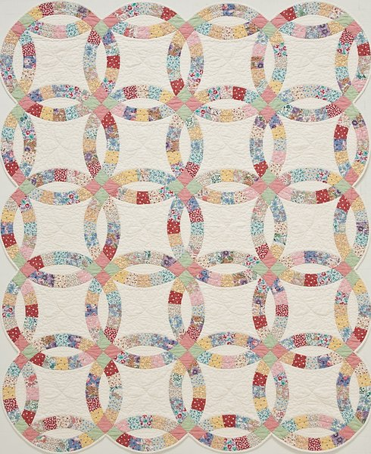

Sourer: <http://www.mrquilt.com/gallery/10/>

* Mariner Compass Quilt

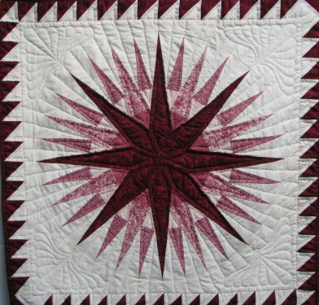

Source: <http://www.cottagecraftworks.com/quilts-amish-quilts-mariner-compass-quilt-p-153.html>

* Amish Bali Quilt

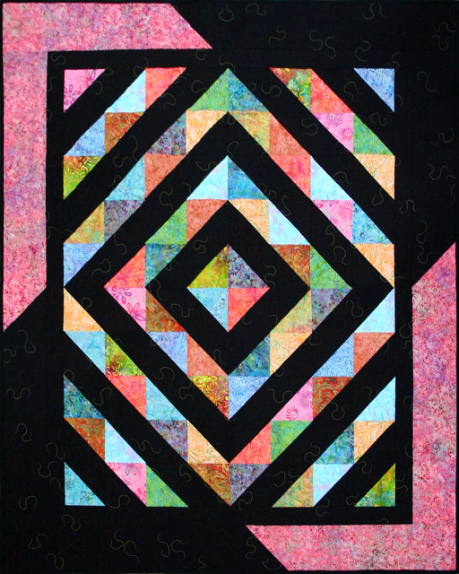

Source: <http://blog.tv-sewingcenter.com/quilting/new-quilt-pattern-amish-revisit-bali/>

* Spinning Star Quilt

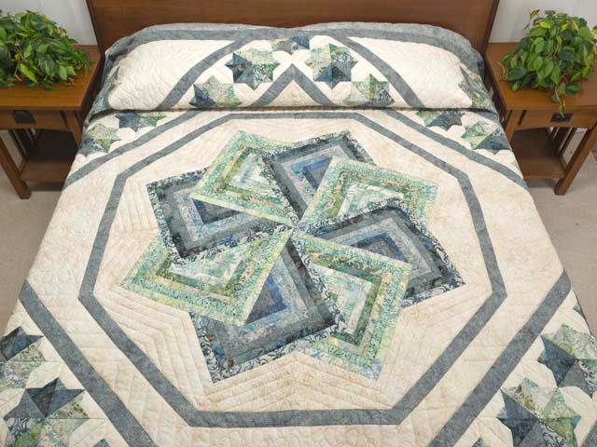

Source: <http://idyllicneedle.net/cabin-quilt/>

* Light In The Valley Quilt

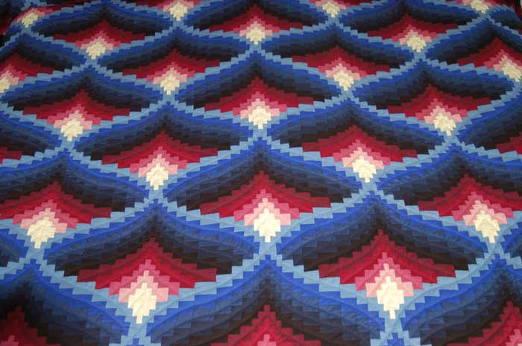

Source: <http://www.almost-amish.com/quiltpages/designs.html>

***Trapunto Quilts***

* Shadow Quilt

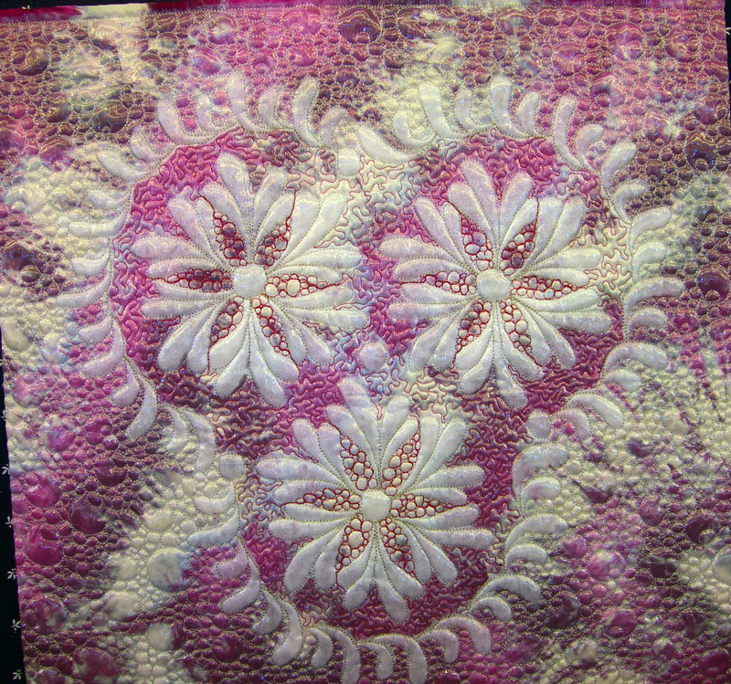

Source: <http://blacktaildesign.com/art-quilts/finished-shadow-trapunto/>

* Pansy Quilt

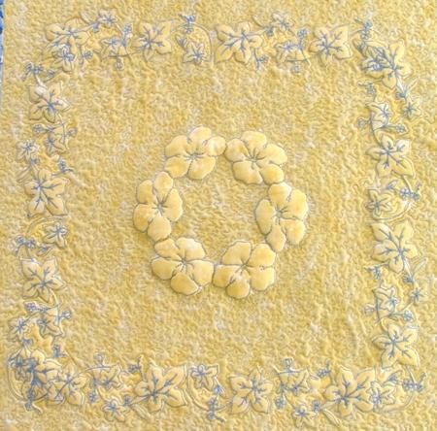

Source: <https://www.advanced-embroidery-designs.com/projects2/guide_trapunto.html>

* Wash Away Quilt

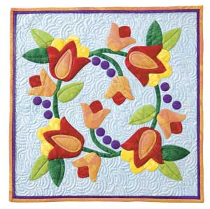

Source: <http://www.quiltersnewsletter.com/articles/Easy_Lesson__Wash_Away_Trapunto>

* Dancing Feathers Quilt

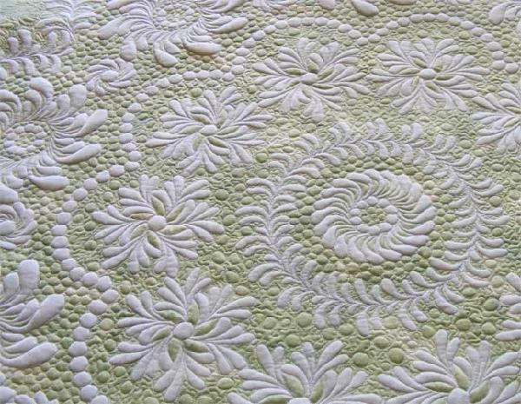

Source: http://www.quiltingboard.com/pictures-f5/my-shadow-trapunto-quilts-t19838.html

* Bird Quilt

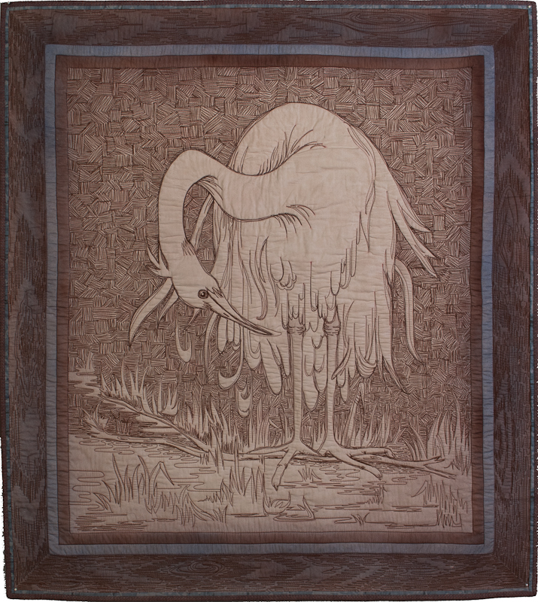

Source: <http://www.hariwalner.com/quilts>

* Tulip Quilt

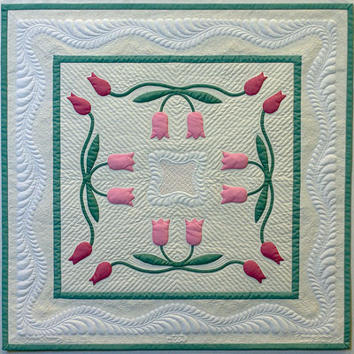

source: http://www.dianeloomisquilts.com/gallery/MayTulips.htm